
REPUBLIC OF CAMEROON
PEACE-WORK-FATHERLAND
UNIVERSITY OF BUEA
FACULTY OF ENGINEERING AND TECHNOLOGY

DEPARTMENT OF COMPUTER ENGINEERING

CEF 440: INTERNET PROGRAMMING AND MOBILE PROGRAMMING
TASK 4: SYSTEM MODELLING AND DESIGN

COURSE INSTRUCTOR: Dr. Nkemeni Valery

PRESENTED BY GROUP 8:

SALLE YIMNAI BRYAN NZUME ETUGE: FE23A140
FONGANG FAITH ACHO: FE23A059
ANDIGEMA JOYCE ANI: FE23A012
MANIKEU TINKEU MARIE ANGE PRINCESSE: FE23A086
NDIP SAMUEL AGBOR OJONG: FE23A101

Table of Contents

Table of Contents i
1. Introduction 1
1.1 Task Objectives 1
1.2 System Overview 1
1.3 Modelling Tool 1
2. Context Diagram 3
2.1 Diagram 3
2.2 Description and Rationale 3
3. Data Flow Diagram - Level 0 5
3.1 Diagram 5
3.2 Process and Data Store Descriptions 5
3.2.1 Processes 5
3.2.2 Data Stores 6
4. Use Case Diagram 8
4.1 Diagram 8
4.2 Actor Descriptions 8
4.3 Use Case Descriptions 9
5. Sequence Diagrams 11
5.1 UC01 - Scan a Warning Light 11
5.2 UC02 - Search Warning Light Manually 12
5.3 UC03 - Diagnose Engine Sound 13
5.4 UC04 - View Repair Suggestions 14
5.5 UC05 - Use App Offline 15
5.6 UC06 - View Diagnosis History 16
5.7 UC07 - Acknowledge Safety Prompt 17
5.8 UC08 - Sync Fault Database 18
6. Class Diagram 20
6.1 Diagram 20
7. Deployment Diagram 23
7.1 Diagram 23
8. Conclusion 25
References 26

1. Introduction

1.1 Task Objectives
This report presents the complete system modelling and design phase of the Mobile Application For Car Diagnostics project. As specified in the course outline, Task 4 requires the production of the following diagrams:
- Context Diagram - illustrating the system boundary and all external actors
- Data Flow Diagram - showing how data moves through the system
- Use Case Diagram - capturing all actors, use cases, and their relationships
- Sequence Diagrams - detailing the step-by-step interaction flows for each use case
- Class Diagram - defining the core data model, attributes, methods, and relationships
- Deployment Diagram - describing the physical architecture and runtime environment
Each diagram is grounded in the requirements established in Task 2 (Requirement Gathering) and Task 3 (Requirement Analysis), specifically in the baselined CarDiag Software Requirements Specification Version 1.1 (09 May 2026). All design decisions trace directly to requirements documented in that specification.

1.2 System Overview
CarDiag is an AI-based mobile application that enables car owners to perform preliminary fault diagnosis using only their smartphone. The application provides three diagnostic pathways: camera-based warning light recognition, engine sound recording and classification, and guided symptom input. For each pathway, the application delivers a structured output comprising a fault explanation, urgency classification, tiered repair suggestions, expert video tutorial links (when online), a confidence indicator, and a mandatory safety disclaimer with mechanic referral prompt.
The application is designed to operate fully offline for all core features, using on-device machine learning inference and a bundled SQLite knowledge base. Online connectivity is required only for expert video links and database synchronisation, both of which are Version 2 features.

1.3 Modelling Tool
All diagrams in this report were produced using Draw.io (diagrams.net), a free and open-source diagramming application available at https://app.diagrams.net. Draw.io was selected for the following reasons:
- It supports all required UML and structured diagram types natively, including use case, sequence, class, and deployment diagrams.
- It produces diagrams in an open XML-based format (.drawio files), ensuring long-term accessibility and editability.
- It can export diagrams to PNG, SVG, and PDF for inclusion in reports.
- It is freely available to all team members without licensing requirements, consistent with the project context.
Diagrams in this report are presented as exported PNG images. The source .drawio files are maintained in the project repository for reference and future editing.

2. Context Diagram

2.1 Diagram
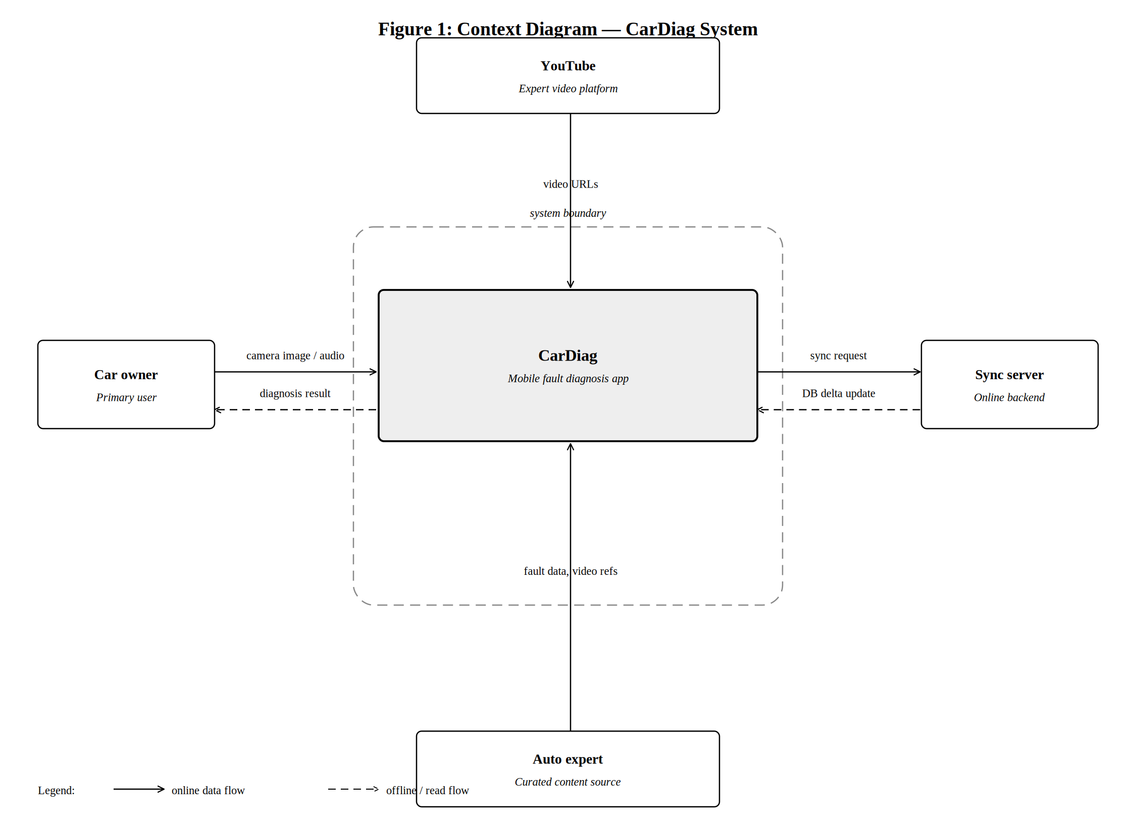
Figure 1: Context Diagram - CarDiag System

2.2 Description and Rationale
The context diagram defines the boundary of the CarDiag system and identifies all external entities that interact with it. The system boundary encompasses all functionality delivered by the CarDiag mobile application; everything outside the boundary is an external actor.
Four external actors are identified:
External Actor | Role and Interaction
Car owner (Primary user) | The main target user of the application. Provides camera images of dashboard warning lights, audio recordings of engine sounds, and symptom descriptions as inputs. Receives diagnosis results, urgency classifications, repair suggestions, and safety guidance as outputs. This is the only actor who interacts with the system in real time during a diagnostic session.
Sync server (Online backend) | A backend server operated by the development team. Sends delta update packages to the application containing new fault database records, updated urgency mappings, and refreshed video URL registries. The application sends synchronisation requests to this server when connectivity is available. This interaction is optional and deferred to Version 2.
YouTube (Expert video platform) | The platform hosting expert car maintenance tutorial videos. The CarDiag application retrieves a curated registry of YouTube video URLs from the sync server and presents these links to the user within the repair suggestion screen. Direct API calls to YouTube are not made; the application uses a curated static URL list in Version 1.
Automotive expert (Curated content source) | Mechanics and automotive professionals who contributed their domain knowledge during the requirements gathering phase (Task 2). Their expertise informs the content of the offline knowledge base - fault descriptions, urgency criteria, repair suggestions, and audio fault categories. They interact with the system indirectly via the admin CMS on the sync server, not in real time.

The data flows shown in the context diagram reflect the key principles established during requirement validation: all data flows involving the car owner (camera images, audio recordings) are processed entirely on-device; no raw sensor data is transmitted to external entities. The sync server and YouTube interactions are online-only and do not affect offline functionality.

3. Data Flow Diagram - Level 0

3.1 Diagram
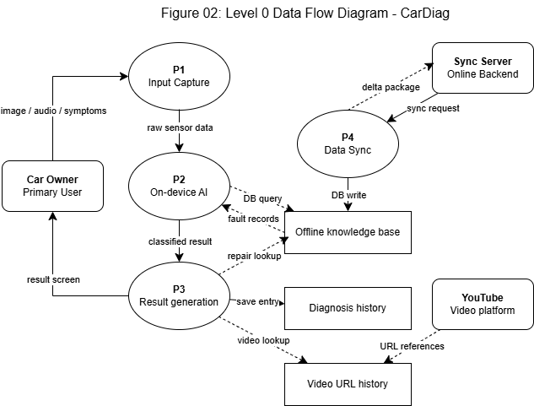

Figure 2: Level 0 Data Flow Diagram - CarDiag

3.2 Process and Data Store Descriptions
The Level 0 DFD decomposes the CarDiag system into four top-level processes and three data stores, showing how data flows between them and between the system and its external actors.

3.2.1 Processes
Process ID | Name | Description
P1 | Input capture | Accepts raw sensor data from the car owner: a camera image capture, an audio recording of engine sound (up to 30 seconds), or structured symptom text from the guided questionnaire. Passes the raw data to P2 for classification.
P2 | On-device AI | Receives raw sensor data from P1. For image input, passes the bitmap to the TF Lite image classifier; for audio input, extracts MFCC features and passes them to the TF Lite audio classifier. Returns a classification result comprising a predicted fault category and a confidence score. Queries DS1 (Offline knowledge base) to retrieve the matching fault record. Passes the classified result and fault record to P3.
P3 | Result generation | Receives the classified result and fault record from P2. Queries DS1 for repair suggestions and preventive maintenance tips. Queries DS3 for matching video URLs (online only). Constructs the complete result output: fault explanation, urgency badge, confidence indicator, tiered repair suggestions, video links, and safety disclaimer. Writes a history entry to DS2. Renders the result screen for the car owner.
P4 | Data sync | Operates as a background service when the device has internet connectivity. Polls the sync server for a database version number. If the remote version is newer than the local version stored in DS1, downloads a delta update package and applies it to DS1. Updates video URL records in DS3. This process is deferred to Version 2.

3.2.2 Data Stores
Store ID | Name | Contents and Access Pattern
DS1 | Offline knowledge base | SQLite database bundled within the application installation package. Contains: warning light symbol definitions, fault descriptions, most likely and other possible causes, urgency codes, engine generation tags, vehicle make/model compatibility data, repair suggestions (tiered: no tools, basic tools, workshop), and preventive maintenance tips. Read by P2 and P3; written by P4 (sync). Available offline from first launch. Extended via online sync in Version 2.
DS2 | Diagnosis history | Encrypted local storage containing all past diagnosis sessions for the current device. Each entry records: session ID, timestamp, input type (camera/audio/manual), identified fault or symbol, urgency level, confidence score, and an optional user-editable note. Written by P3 after each completed session; read by the history screen. Never transmitted to any remote server.
DS3 | Video URL registry | A curated registry mapping fault categories to YouTube video URLs with associated metadata (title, channel, estimated duration in seconds). In Version 1, this is a static JSON file bundled with the application and updated only via app updates. In Version 2, it is updated by P4 via the sync server. Read-only from P3's perspective.

4. Use Case Diagram

4.1 Diagram
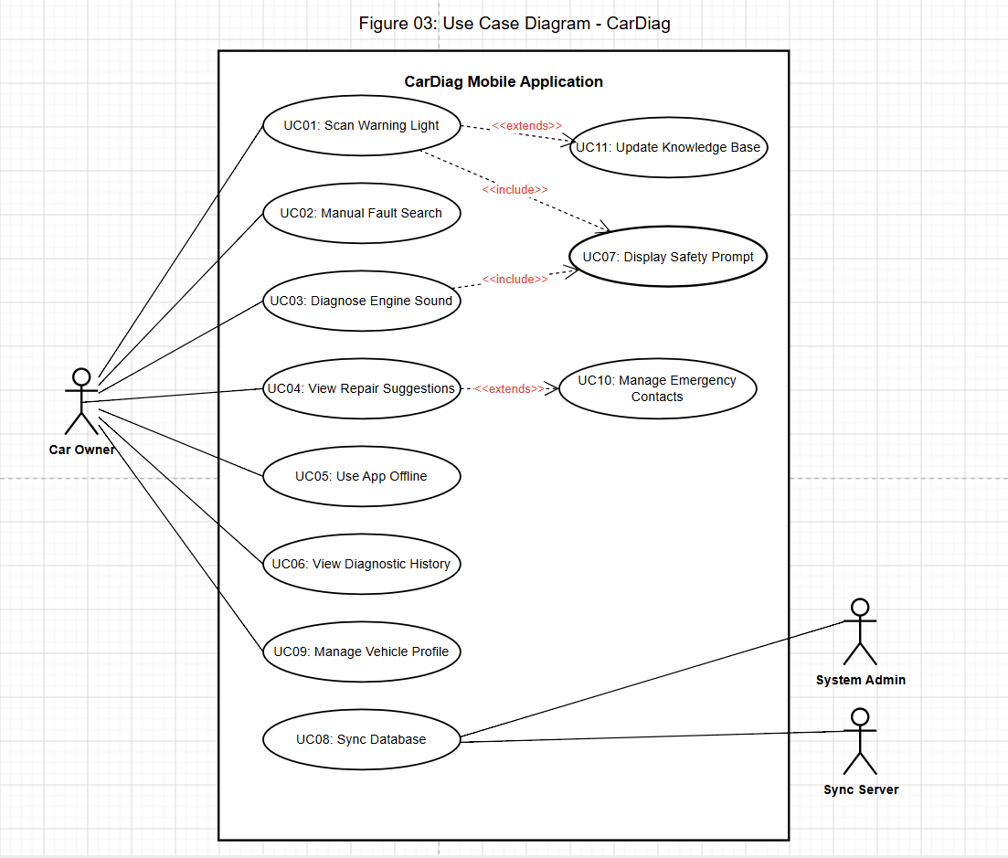
Figure 3: Use Case Diagram - CarDiag

4.2 Actor Descriptions
Actor | Description
Car owner | The primary actor. A non-technical vehicle owner or driver who uses the application to identify and understand dashboard warning lights or unusual engine sounds. Initiates all diagnostic and history management use cases.
System administrator | A member of the development team responsible for maintaining the online fault database and video URL registry. Triggers the database synchronisation process via the admin CMS. Not an in-app user.
Sync server | The online backend system that participates in the UC08 (Sync fault database) use case by supplying delta update packages in response to synchronisation requests from the application.

4.3 Use Case Descriptions
ID | Use Case | Actor(s) | Brief Description
UC01 | Scan a warning light | Car owner | User taps the camera scan entry point, captures an image of the dashboard, and receives a warning light explanation with urgency, confidence score, repair suggestions, and safety disclaimer. Includes UC07 (safety prompt) for High/Critical results. Extends UC11 (manual fallback) when confidence is low.
UC02 | Search warning light manually | Car owner | User navigates to the manual search screen, types a keyword or browses by category, and selects a symbol from the offline database. The result screen is identical to UC01's output.
UC03 | Diagnose engine sound | Car owner | User acknowledges the safety instruction screen, passes the ambient noise check (FR05a), records up to 30 seconds of engine audio, receives an audio classification result with follow-up questions, and views a refined fault assessment with urgency, confidence, and repair suggestions. Includes UC07 for High/Critical results.
UC04 | View repair suggestions | Car owner | From any result screen, the user accesses the repair suggestion screen displaying three tiers of guidance (no tools, basic tools, workshop-only), preventive tips, and expert video links (when online). Extends UC10 (view expert video).
UC05 | Use app offline | Car owner | User operates the application with no internet connection. All core features (UC01, UC02, UC03, UC04, UC06, UC07) are available using the bundled database and on-device models. Video links (UC10) are unavailable; an offline fallback message is shown.
UC06 | View diagnosis history | Car owner | User navigates to the history screen to review past diagnosis sessions in reverse chronological order. Can add or edit a note on any entry, and delete individual entries.
UC07 | Acknowledge safety prompt | Car owner | Triggered automatically when a diagnosis result has High or Critical urgency. A non-dismissible modal is displayed. The acknowledgement button is disabled for a minimum of three seconds. Critical urgency modals also offer an emergency mechanic contact call option (FR14a).
UC08 | Sync fault database | Sys admin + Sync server | The system administrator updates the online fault database via the admin CMS. The sync server notifies or responds to the application's polling request with a database version number. If a newer version is available, a delta package is downloaded and applied to the local SQLite database. Version 2 feature.
UC09 | Configure emergency contact | Car owner | User navigates to Settings and saves up to three mechanic contact numbers. These numbers are offered as direct-call options within the Critical urgency safety modal (UC07).
UC10 | View expert video | Car owner | Extends UC04. When the device is online, the user taps a video link on the repair suggestion screen. The application opens YouTube in the device browser. Available online only.
UC11 | Manual scan fallback | Car owner | Extends UC01. Triggered when the image classifier returns a confidence score below the defined threshold. The application displays a 'Symbol not recognized' message and a prominent button routing the user to the manual search (UC02).

5. Sequence Diagrams
Sequence diagrams are provided for each of the eight use cases defined in the use case diagram. Each diagram follows the UML 2.5 sequence diagram notation: lifelines are represented as named boxes with dashed vertical lines, activation bars show the period during which each object is active, solid horizontal arrows represent synchronous messages, dashed arrows represent return values or asynchronous responses, and combined fragments (alt, opt, loop) capture conditional and optional behaviour.

5.1 UC01 - Scan a Warning Light
The warning light scan sequence is the primary diagnostic flow and the most architecturally significant interaction in CarDiag. It involves five lifelines: the car owner, the UI layer (CameraScreen), the on-device ML service (ImageClassifier), the SQLite knowledge base, and the ResultView screen. The sequence includes an alt fragment for the confidence check - distinguishing the high-confidence path (which triggers a full database lookup and result screen) from the low-confidence path (which triggers the manual fallback). An opt fragment captures the non-dismissible safety modal for High and Critical urgency results. The session is saved to the diagnosis history only after the result is successfully delivered.
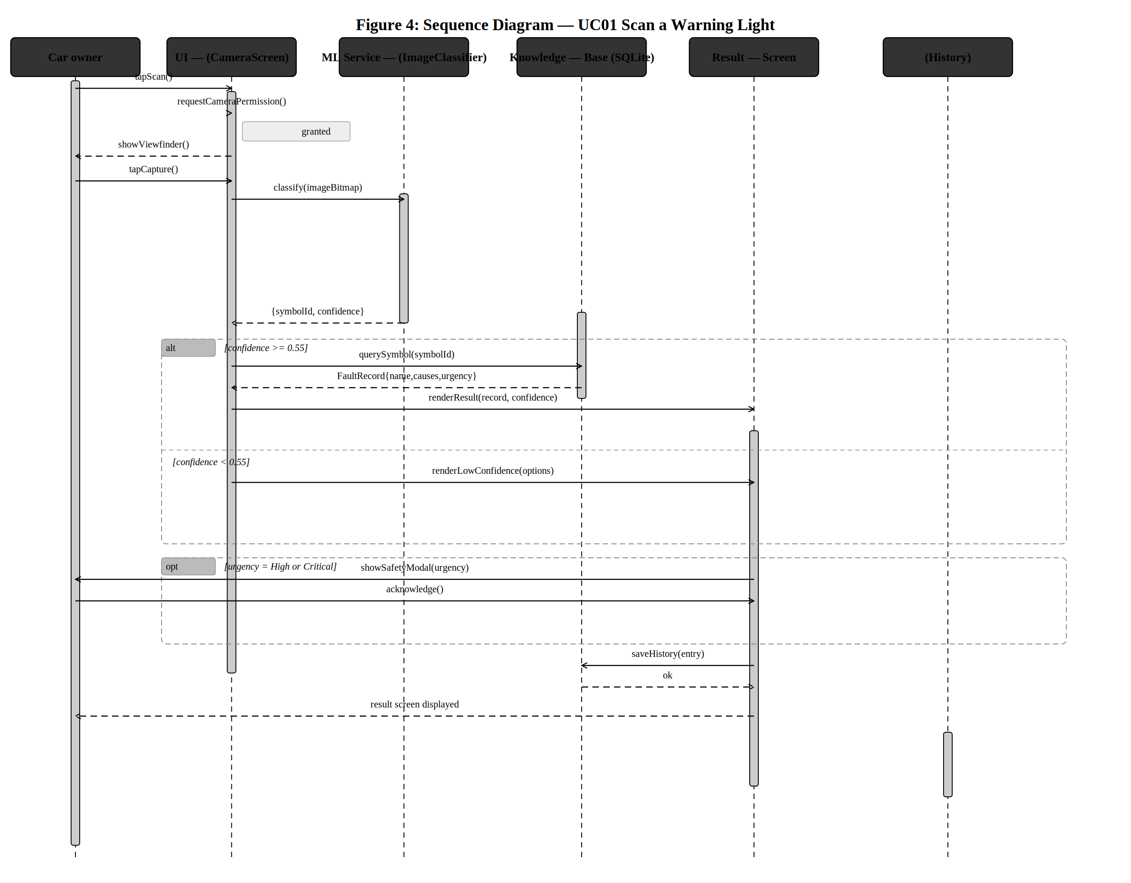
Figure 4: Sequence Diagram - UC01 Scan a Warning Light

5.2 UC02 - Search Warning Light Manually
The manual search sequence demonstrates the live search behaviour specified in NFR04: results must update within 500 ms of each keystroke. The sequence includes a loop fragment covering the repeated keystroke-search cycle, a second database query on symbol selection (which retrieves the full fault record rather than the abbreviated search summary), and the same result screen output as UC01. This use case is the primary offline diagnostic pathway for users who either could not use the camera or prefer to look up a symbol directly.
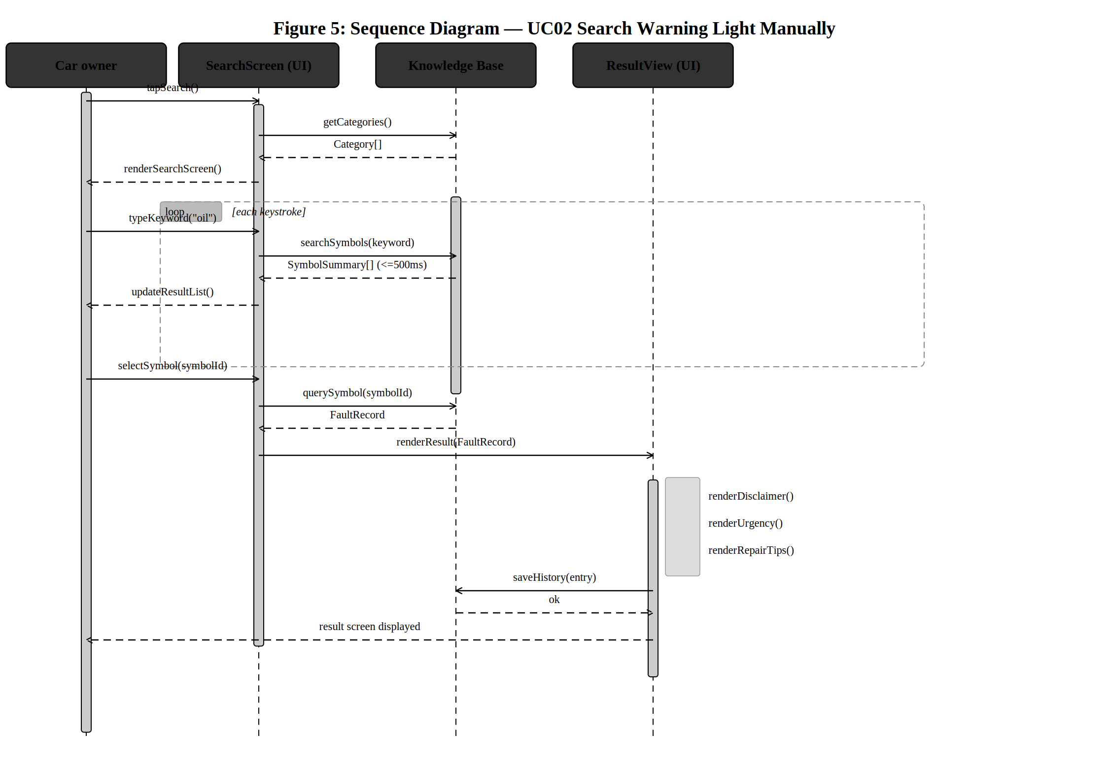
Figure 5: Sequence Diagram - UC02 Search Warning Light Manually

5.3 UC03 - Diagnose Engine Sound
The engine sound diagnosis sequence is the most complex in the application, involving six lifelines. It incorporates the mandatory safety instruction screen with the four-second button delay (FR18), the ambient noise level check (FR05a - a new requirement added during Buea validation), the audio buffer retention requirement (FR05 - retained for 30 minutes to allow re-processing), the TF Lite audio classification with MFCC extraction, and the follow-up questions (FR07). The confidence check alt fragment determines whether a specific fault name is displayed or a generic consultation message is shown. This reflects the heightened confidence threshold for safety-critical audio fault categories established in NFR03.
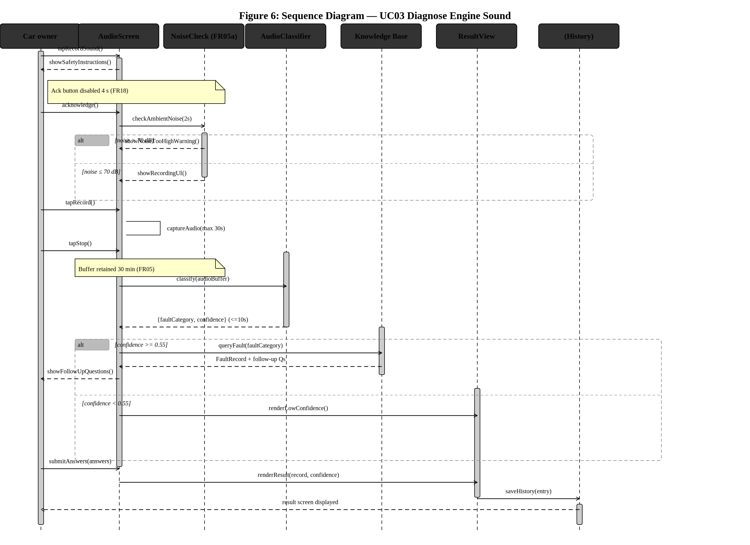
Figure 6: Sequence Diagram - UC03 Diagnose Engine Sound

5.4 UC04 - View Repair Suggestions
The repair suggestions sequence shows the three-tier guidance model (no tools, basic tools, workshop-only) established during the structured walkthrough in Buea (WK-06). A separate database query retrieves preventive maintenance tips, distinct from the repair suggestions. An opt fragment captures the online video link lookup from the video URL registry, including the priority ordering rule for videos under five minutes in duration (WK-09). The sequence ends with an opt fragment showing the system browser opening YouTube when the user taps a video link.
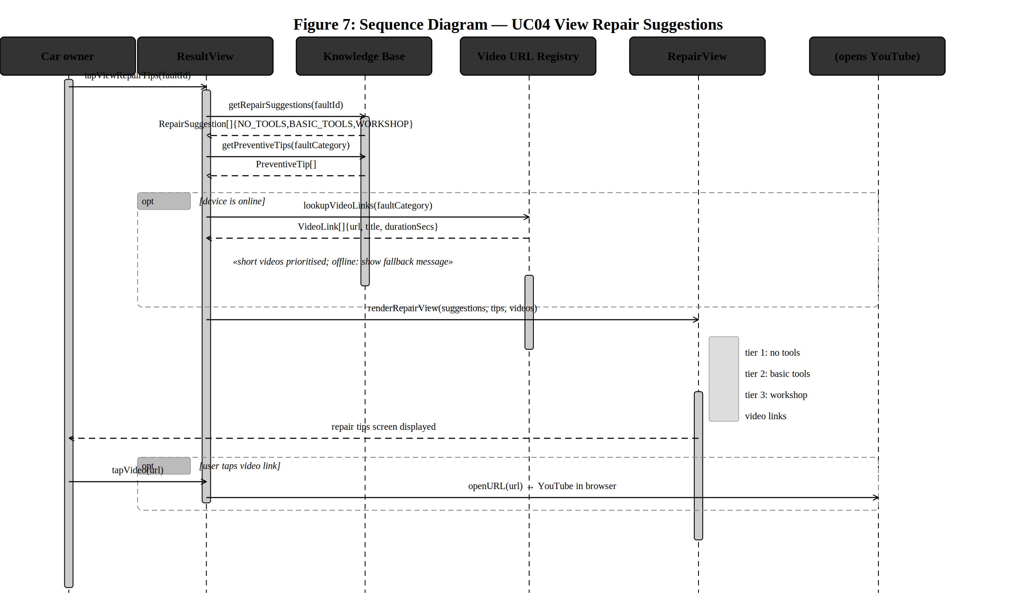
Figure 7: Sequence Diagram - UC04 View Repair Suggestions

5.5 UC05 - Use App Offline
The offline use sequence establishes the architectural guarantee of FR11 and NFR02: all core features must be available from the first launch of the application with no internet connection. The sequence shows that both the TF Lite models and the SQLite database are loaded directly from the application's bundled assets - no network request is made at any point. A postcondition note confirms zero outbound network calls. The video section shows the offline fallback message. The history read at the end of the sequence confirms that diagnosis history also operates entirely from local encrypted storage.
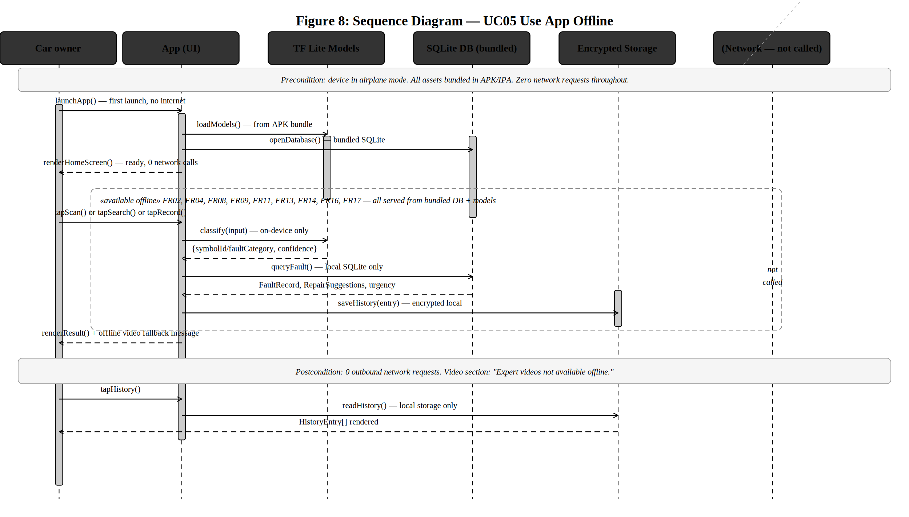
Figure 8: Sequence Diagram - UC05 Use App Offline

5.6 UC06 - View Diagnosis History
The diagnosis history sequence covers the full read-manage-edit lifecycle of past diagnosis entries. All operations are local - no network access is involved at any point. An opt fragment covers the user adding or editing a note on an entry, with the detail view refreshing after the note is saved. A second opt fragment covers the deletion flow, which requires explicit user confirmation before the entry is permanently removed from local storage.
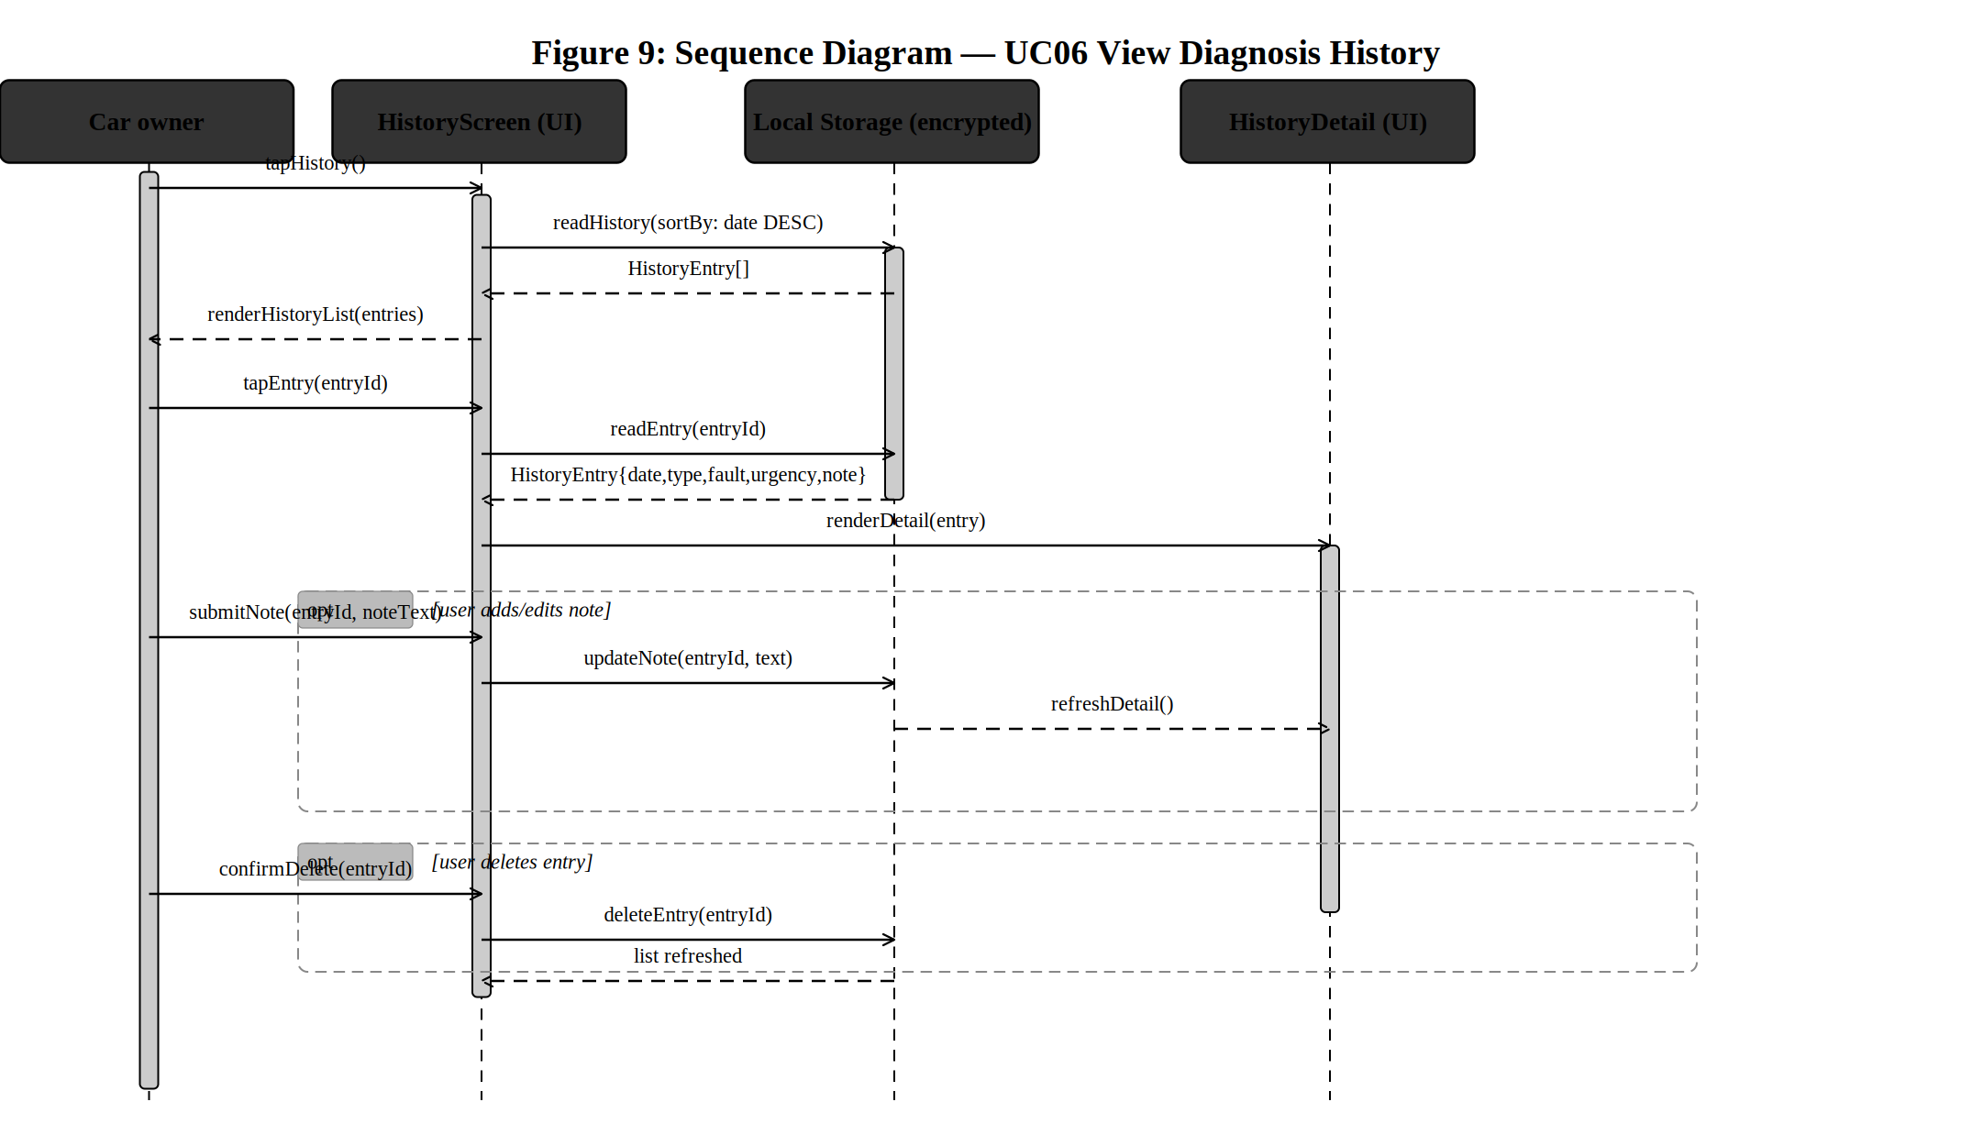
Figure 9: Sequence Diagram - UC06 View Diagnosis History

5.7 UC07 - Acknowledge Safety Prompt
The safety prompt sequence is the safety-critical interaction at the heart of CarDiag's trust model. An alt fragment distinguishes Critical from High urgency responses: Critical urgency triggers a lookup of saved emergency mechanic contact numbers (FR14a) before the modal is displayed, adding call-to-mechanic buttons alongside the acknowledgement. Both paths disable the acknowledgement button for a minimum of three seconds (FR14). A guard annotation confirms that the back button and outside-tap gestures are no-ops (Constraint C07). The session history is saved only after the acknowledgement is received.
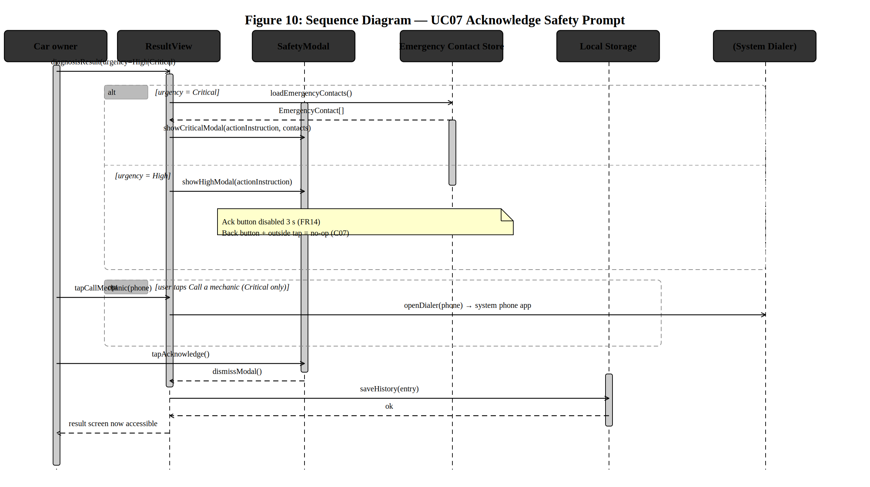
Figure 10: Sequence Diagram - UC07 Acknowledge Safety Prompt

5.8 UC08 - Sync Fault Database
The database synchronisation sequence demonstrates the Version 2 online update mechanism. The sync service polls the server for a version number; if a newer version is available, it downloads and applies a delta package containing updated fault records and video URLs. An alt fragment distinguishes the update path from the no-update path. The sync operates as a background process and notifies the UI on completion. If no connection is available, the sequence does not begin - the application continues to use the current local database version.
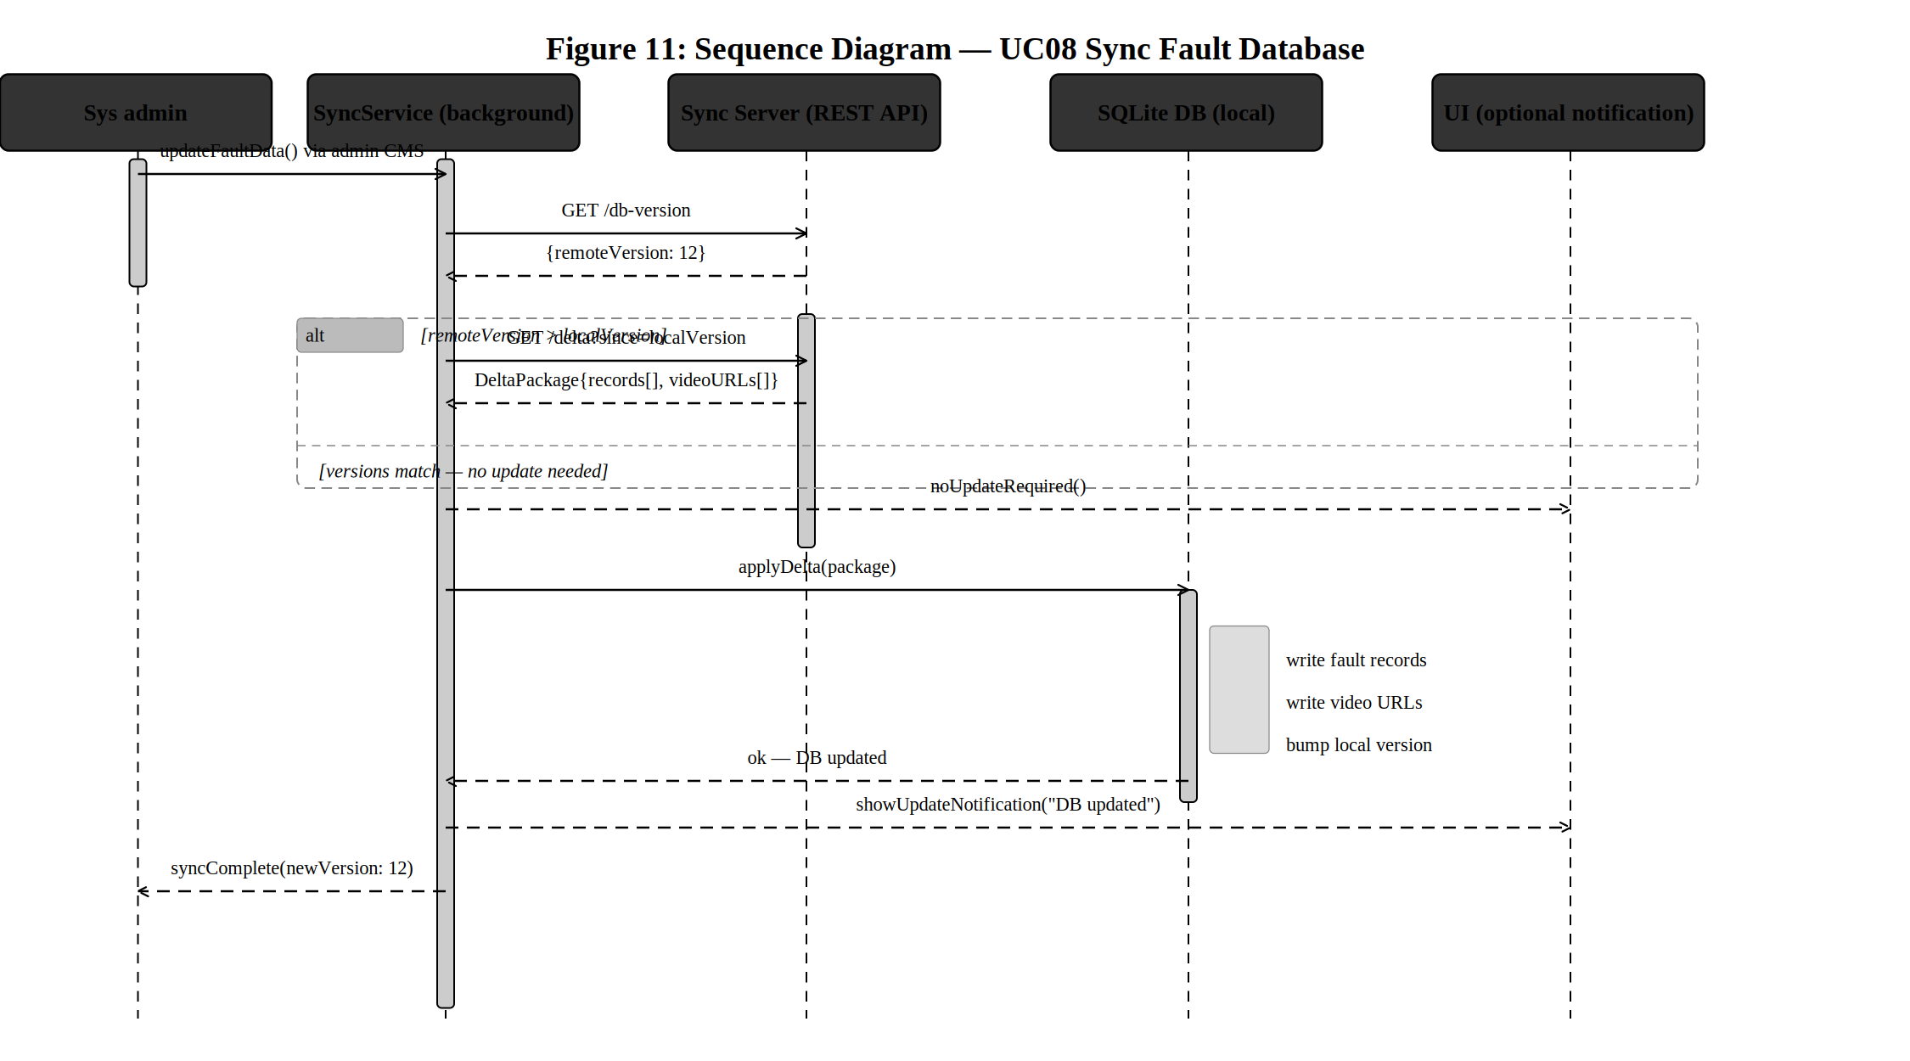
Figure 11: Sequence Diagram - UC08 Sync Fault Database

6. Class Diagram

6.1 Diagram
The class diagram presents the core object-oriented data model for CarDiag. All class names, attributes, and methods are derived directly from the functional requirements in SRS v1.1. The diagram is rendered at a level of abstraction appropriate for the design phase - it specifies the structure and relationships that the development team will implement, without prescribing the internal logic of each method.
The diagram uses standard UML 2.5 class notation. Associations show multiplicity at each end. Two enumerations (UrgencyLevel and SuggestionTier) define the controlled vocabulary used throughout the data model.
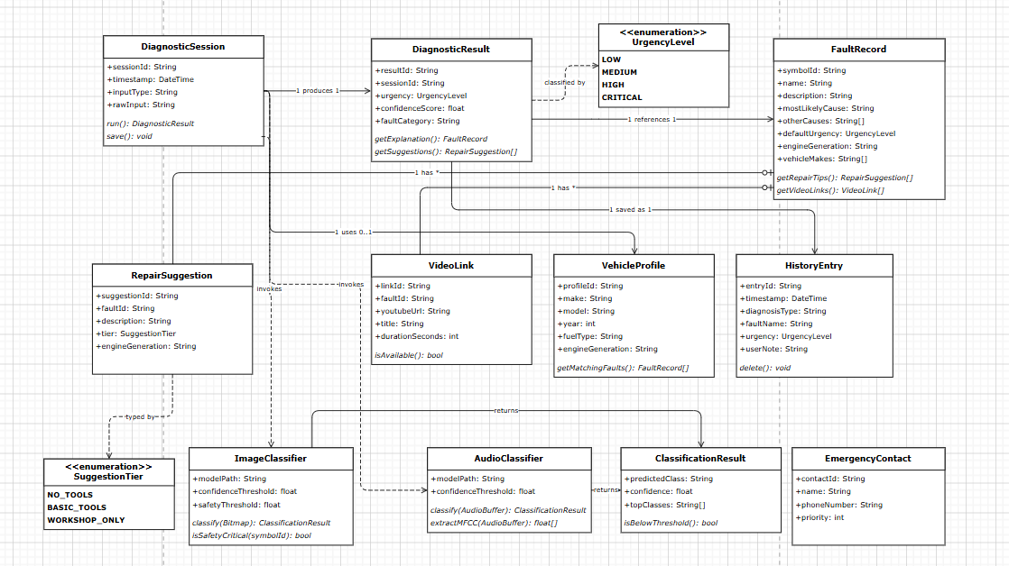
Figure 12: Class Diagram

The following table provides a textual specification of all classes before the rendered diagram:
Class | Key Attributes | Key Methods / Purpose
DiagnosticSession | sessionId, timestamp, inputType (image/audio/manual), rawInput | run(): DiagnosticResult - orchestrates the full diagnostic pipeline. save(): persists the session. Uses VehicleProfile optionally to filter results. Invokes ImageClassifier or AudioClassifier based on inputType.
DiagnosticResult | resultId, sessionId, urgency: UrgencyLevel, confidenceScore: float, faultCategory | getExplanation(): FaultRecord - retrieves the full fault description. getSuggestions(): RepairSuggestion[] - retrieves tiered repair guidance. Saved as a HistoryEntry on completion.
FaultRecord | symbolId, name, description, mostLikelyCause, otherCauses: String[], defaultUrgency, engineGeneration, vehicleMakes: String[] | getRepairTips(): RepairSuggestion[] - returns the three-tier suggestion set. getVideoLinks(): VideoLink[] - returns curated video URLs. The engineGeneration field addresses GAP-08 identified during requirements validation.
RepairSuggestion | suggestionId, faultId, description, tier: SuggestionTier, engineGeneration | Stores a single repair instruction. The SuggestionTier enumeration (NO_TOOLS, BASIC_TOOLS, WORKSHOP_ONLY) implements the three-tier guidance model established in WK-06.
VideoLink | linkId, faultId, youtubeUrl, title, durationSeconds: int | isAvailable(): bool - checks whether the URL is still resolvable. Duration is stored to enable the short-video prioritisation rule (WK-09, videos under 300 seconds preferred).
VehicleProfile | profileId, make, model, year, fuelType, engineGeneration | getMatchingFaults(): FaultRecord[] - filters the knowledge base to vehicle-specific records. Allows generic fallback when no vehicle-specific record exists.
HistoryEntry | entryId, timestamp, diagnosisType, faultName, urgency: UrgencyLevel, userNote | delete(): removes the entry from local encrypted storage. userNote is an optional free-text field added by the user from the history detail screen (UC06).
ImageClassifier | modelPath (TF Lite .tflite file), confidenceThreshold (default: 0.55), safetyThreshold (default: 0.85) | classify(Bitmap): ClassificationResult - runs the image through the quantized CNN model. isSafetyCritical(symbolId): bool - determines whether the higher safety threshold applies (NFR03).
AudioClassifier | modelPath (TF Lite .tflite file), confidenceThreshold (default: 0.55) | classify(AudioBuffer): ClassificationResult - extracts MFCC features and passes them to the audio classification model. extractMFCC(AudioBuffer): float[] - produces the feature vector for the model.
ClassificationResult | predictedClass: String, confidence: float, topClasses: String[] | isBelowThreshold(): bool - used by both classifiers to trigger the low-confidence fallback path. When true for a safety-critical class, the specific fault name is suppressed.
EmergencyContact | contactId, name, phoneNumber, priority: int | Stores a mechanic contact number saved by the user in Settings. Priority determines the order of display in the Critical urgency modal (FR14a, added during Buea validation).
SuggestionTier (enum) | NO_TOOLS, BASIC_TOOLS, WORKSHOP_ONLY | Enumeration controlling the display tier of each RepairSuggestion on the repair screen.
UrgencyLevel (enum) | LOW (1), MEDIUM (2), HIGH (3), CRITICAL (4) | Enumeration used by DiagnosticResult, FaultRecord, and HistoryEntry. Value determines modal type (opt for HIGH, non-dismissible for CRITICAL).

7. Deployment Diagram

7.1 Diagram
The deployment diagram specifies the physical distribution of CarDiag's software components across runtime execution environments. It identifies three deployment nodes: the mobile device (primary execution environment), the backend sync server (online-only, Version 2), and YouTube (external platform).
The diagram uses UML 2.5 deployment notation: nodes are represented as three-dimensional boxes, artifacts are files or executables deployed within nodes, components are logical subsystems, and communication associations show the protocol and connection type between nodes.
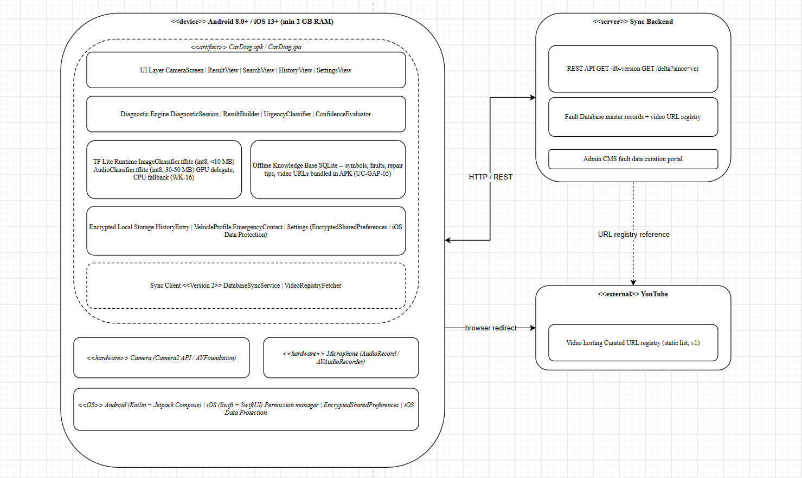

Figure 13: Deployment diagram

The following table describes each node and its components before the rendered diagram:
Node / Component | Description
Node: Mobile device (Android 8.0+ / iOS 13+) | The primary execution environment. Minimum specification: 2 GB RAM, 100 MB free storage. Runs the CarDiag application package (APK on Android, IPA on iOS) and all on-device components. No network connection is required for core functionality.
UI layer | Comprises all screens: CameraScreen, ResultView, SearchView, HistoryView, SettingsView. Built with Kotlin + Jetpack Compose (Android) or Swift + SwiftUI (iOS). Handles permission requests, renders all result content, and manages navigation.
Diagnostic engine | Contains the core business logic classes: DiagnosticSession, ResultBuilder, UrgencyClassifier, and ConfidenceEvaluator. Orchestrates the diagnostic pipeline from input capture through to result delivery.
TF Lite runtime | Hosts two quantized ML model files: ImageClassifier.tflite (warning light recognition, int8 quantization, under 10 MB) and AudioClassifier.tflite (engine sound classification, int8 quantization, 30–50 MB). Both operate entirely on-device. GPU delegate acceleration is used when available; CPU-only fallback is required when the GPU delegate is unsupported (WK-16).
Offline knowledge base (SQLite) | The bundled SQLite database containing all fault records, symbol definitions, repair suggestions, video URL registry, and urgency mappings. Included in the application installation package so that offline features are available from first launch. Updated via online sync in Version 2.
Encrypted local storage | Stores user-generated data: HistoryEntry records, VehicleProfile, EmergencyContact list, and user settings. Uses Android EncryptedSharedPreferences / EncryptedFile or iOS Data Protection APIs. Never transmitted to any remote server.
Sync client (Version 2) | Background service comprising DatabaseSyncService and VideoRegistryFetcher. Polls the sync server for database version numbers and applies delta updates to the local SQLite database. Operates only when the device has an active internet connection.
Camera sensor (hardware) | Accessed via Android Camera2 API or iOS AVFoundation. Provides image capture for the warning light scanner. Permission requested at first use with user-visible rationale.
Microphone (hardware) | Accessed via Android AudioRecord or iOS AVAudioRecorder. Captures audio at 16 kHz, 16-bit, mono for the engine sound classifier. Permission requested at first use with user-visible rationale.
Node: Sync server (backend) | An internet-accessible server operated by the development team. Hosts the REST API (GET /db-version, GET /delta), the master fault database, and the admin CMS. Version 2 feature only.
Node: YouTube (external) | The platform hosting expert maintenance tutorial videos. CarDiag does not make direct API calls to YouTube in Version 1; it opens curated video URLs in the device's native browser. The YouTube Data API v3 may be used in future versions for dynamic content retrieval.
Protocol: HTTPS / REST | All network communication between the mobile device and the sync server uses HTTPS (TLS 1.2 or higher). No raw sensor data is transmitted. The app never communicates over plain HTTP (Constraint C09).

8. Conclusion
This report has presented the complete system modelling and design deliverable for Task 4, fulfilling all six diagram types specified in the CEF 440 course outline. The following table summarises the diagrams produced and their relationship to the project requirements.
# | Diagram | Key Design Decisions Captured
1 | Context Diagram | Four external actors identified. All sensor data flows (camera, audio) confirmed as on-device only. Online interactions (sync, video) explicitly limited to Version 2 or optional online features.
2 | Level 0 DFD | Four processes (P1–P4) and three data stores (DS1–DS3) defined. Offline-first data flow confirmed: P2 and P3 read DS1 without network access. P4 (sync) explicitly separated as an optional background process.
3 | Use Case Diagram | 11 use cases across 3 actors. «include» and «extend» relationships formalise the safety prompt (UC07), manual fallback (UC11), and video viewing (UC10) behaviours.
4–11 | Sequence Diagrams (8 UCs) | All alt/opt/loop fragments grounded in SRS requirements. Validation-driven additions incorporated: FR05a ambient noise check (UC03), 4-second safety card delay (UC03), 3-second modal button delay (UC07), FR14a emergency contacts (UC07), buffer retention (UC03), offline postcondition verification (UC05).
12 | Class Diagram | 13 classes and 2 enumerations. All validation-driven additions reflected: engineGeneration field (GAP-08), three-tier SuggestionTier (WK-06), safetyThreshold on ImageClassifier (WK-15), EmergencyContact class (WK-12, FR14a).
13 | Deployment Diagram | Three nodes. Smartphone-only architecture confirmed. GPU/CPU fallback specified (WK-16). All assets bundled in APK/IPA (UC-GAP-05). Encrypted storage specified for all user data. HTTPS-only network communication (Constraint C09).

The system design is consistent with the baselined CarDiag SRS v1.1 and incorporates all 20 requirement changes identified during the Buea stakeholder validation programme. The diagrams produced in this task will serve as the primary reference for Task 5 (UI Design and Implementation) and Task 6 (Database Design and Implementation).

References
- CarDiag Software Requirements Specification, Version 1.1. Group 8, CEF 440, University of Buea, 09 May 2026.
- Task 3 Requirements Analysis Report. Group 8, CEF 440, University of Buea, May 2026.
- Task 3 Requirements Validation Report. Group 8, CEF 440, University of Buea, May 2026.
- CEF 440 Course Outline. Dr. Valery Nkemeni, University of Buea, Second Semester 2024/2025.
- Draw.io (diagrams.net). JGraph Ltd. https://app.diagrams.net. Accessed May 2026.
- Rumbaugh, J., Jacobson, I., and Booch, G. The Unified Modeling Language Reference Manual, 2nd Edition. Addison-Wesley, 2004.
- Sommerville, I. Software Engineering, 10th Edition. Pearson Education, 2015. Chapters 5 (System Modelling) and 6 (Architectural Design).

